**Algebra II and Algebra II GT**

**Final Exam Review**

**2014-2015**

**Quadratics**

1. Solve for x: 

2. Solve for x: 

3. Solve for x: 

4. Solve for x: 

5. State the number of real roots for the equation 

6. State the nature of the roots for the equation 

7. Create a sketch of a quadratic function with a:

Discriminant =0

Discriminant <0

Discriminant >0

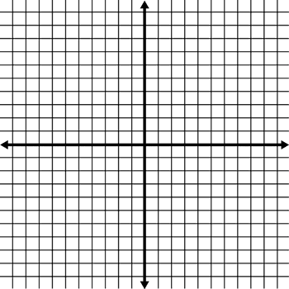

8. Simplify:  9. Simplify: 

10. Simplify:  11. Simplify: 

12. Simplify: 

13. If a toy rocket is launched vertically upward from ground level with an initial velocity of 180 feet per second, then its height *h* after *t* seconds is given by the equation (if air resistance is neglected).

a. How long will it take for the rocket to return to the ground?

b. After how many seconds will the rocket be 112 feet above the ground?

c. How long will it take the rocket to hit its maximum height?

d. What is the maximum height?

14.

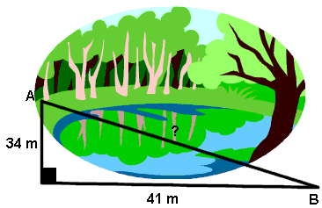

To get from point A to point B you must avoid walking through a pond.  To avoid the pond, you must walk 34 meters south and 41 meters east.  To the *nearest* *meter*, how many meters would be saved if it were possible to walk through the pond?

**Polynomials**

1) Find the zeros of the polynomial.

A.  B. 

2) Write a polynomial in standard form given zeros: 1, 3, -2

3) Divide the following:

A. 

B. 

C. 

D. 

4) How do you know if something is a factor of a polynomial? _________________________________

5) Is  a factor of ?

6) Find  for .

7) Sketch the polynomial  without a calculator

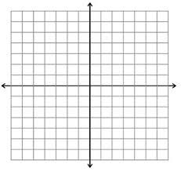Zeros: ______________________

Leading Coefficient(+/-):_________

Degree: _______

x-intercepts: _____________________

y-intercept: ______________________

Left end behavior: _____________________

Right end behavior: ________________________

Behavior at the zeros:

8) Graph with a calculator

For the following function,, find the following:

1. Number of expected zeros:_____________
2. End Behavior:

As x→∞, f(x) → ______

As x→ -∞, f(x) → ______

1. Domain: ______________
2. Range: _______________
3. Absolute Minimum: ___________
4. Absolute Maximum: ___________
5. Relative Maximum: ____________
6. Relative Minimum: ____________
7. Y-Intercept: _____________
8. Zeros: _____________________________
9. Increasing: __________________
10. Decreasing: __________________

9) Expand  GT ONLY

10) Expand  GT ONLY

**Radicals**

Simplify

1)  2)  3) 

4)  5)  6) 

7)  8)  9) 

10)  11)  12) 

Solve for x.

13)  14)  15) 

16) 

Find the following and graph. Plot 3 accurate points.

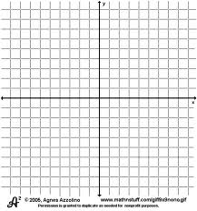

17) 

Domain:__________________

Range: ___________________

Shifts: ___________________

18) 

Domain: __________________

Range: ____________________

Shifts: _____________________

19) Find the Domain AND Range of the function  (GT only)

20) Find the Domain AND Range of the function (GT only)

**Rationals**

Find the following and graph. Include 3 accurate points for each section of the graph.

1) D(x) = 2) U(x) =

Domain: ________________ Domain: ________________

Holes: __________________ Holes: __________________

V. A: ___________________ V. A: ___________________

H. A: ___________________ H. A: ___________________



Simplify.

3)  4)  5) 

6)  7) 

8)  9) 

Solve for x.

10)  11) 

12) 

**Trigonometry**

1) Sketch the arc for  .

2) Sketch the arc for  and find the sine, cosine and tangent of the value.

3) If cos<0and sin<0, what quadrant is in?

4) What is the ?

5) Sketch the triangle formed by the coordinates (-8, 15) and find the six trig functions for .