|  |
| --- |
| Mount Hebron high school |
| Common Core Algebra II |
| Midterm Review for Regular and GT |
|  |
| **MHHS MATH DEPT – CC Alg II Team** |
| **2015 – 2016 school year** |

|  |
| --- |
| This is the midterm review packet that has examples for each topic covered in the Fall semester. These are not the exact problems you will see on the midterm. The purpose of this document is to help you practice problems in order to deepen your understanding of the concepts learned. |

**Unit 1: Family of Functions**

***Directions: For the graphs in #1 and 2, determine the type of function represented in the graph, domain, range, any increasing intervals, any decreasing intervals, symmetry, intervals of continuity and absolute or local extrema.***

1.

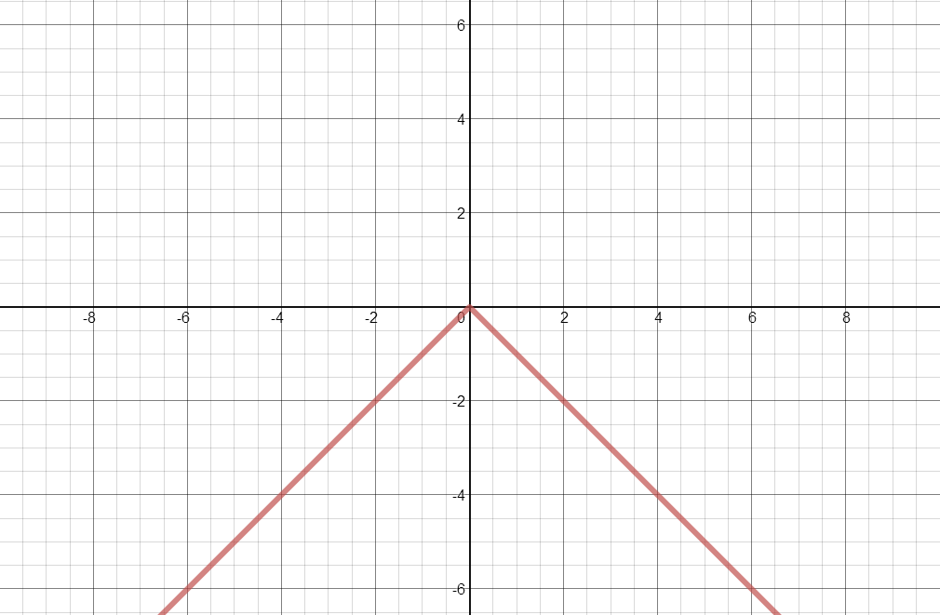Type of Function:______________________

Domain:______________

Range:________________

Intervals of Increasing:___________________

Intervals of Decreasing:___________________

Symmetry:_____________

Intervals of Continuity:____________________

Maximum:_____________ (Absolute or Relative)

Minimum:_____________ (Absolute or Relative)

2.

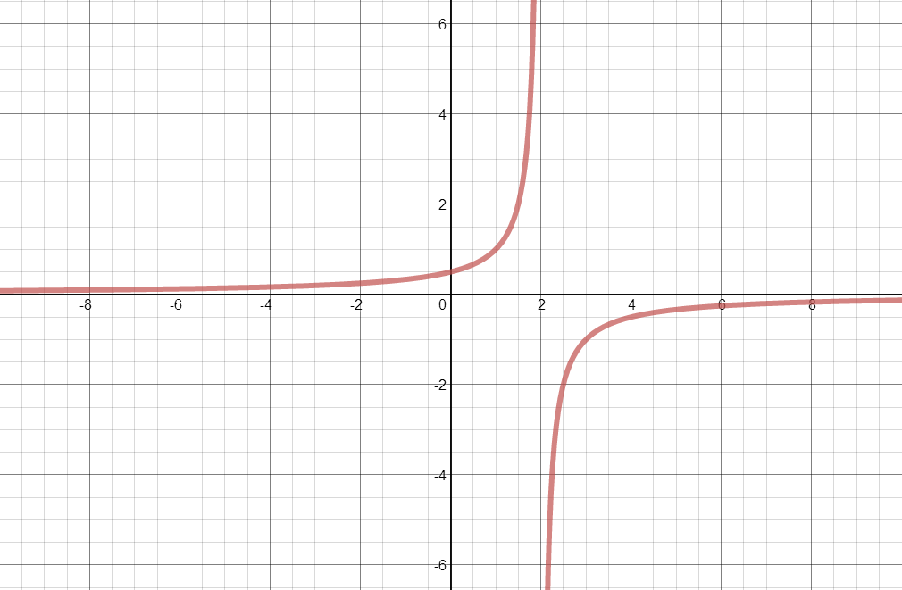Type of function:_________________________

Domain:_______________

Range:________________

Intervals of Increasing:____________________

Intervals of Decreasing:___________________

Symmetry:_______________

Intervals of Continuity:____________________

Maximum: _____________(Absolute or Relative)

Minimum: _____________(Absolute or Relative)

3. **Graph y = x3 – 4x2 + x – 1 in your calculator and find the following:**

Type of Function:______________________

Domain:______________

Range:________________

Intervals of Increasing:___________________

Intervals of Decreasing:___________________

Symmetry:_____________

Intervals of Continuity:____________________

Maximum:_____________ (Absolute or Relative)

Minimum:_____________ (Absolute or Relative)

4. **Sketch an example of each type of symmetry:**

**Even Odd Both**

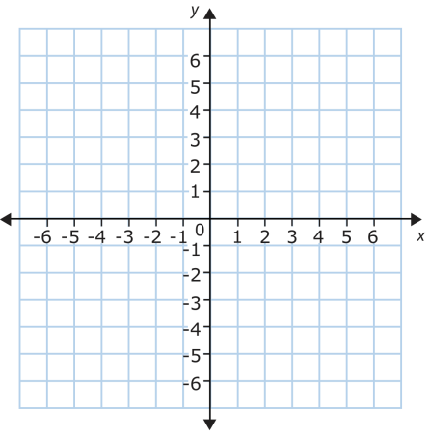

5. Let  model the temperature of a cup of tea in Celsius, after x minutes.

Graph the function

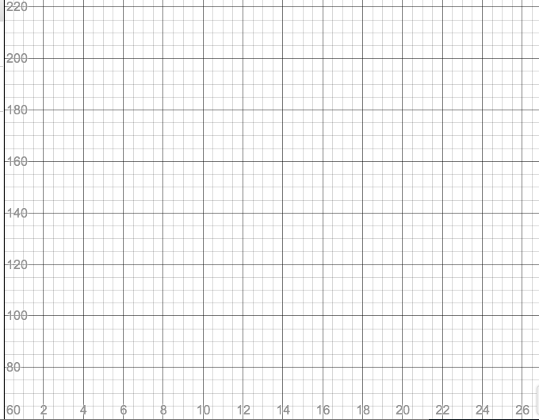

a. Will the inverse be a function? How can you tell by looking at the graph of the original function?

b. What is an easy way to find the domain and range of the inverse? Find the domain and range.

c. What type of symmetry is there between a function and its inverse?

6. Find the inverse for each of the following functions.

|  |  |  |
| --- | --- | --- |
| a. | b. | c. |

***Directions: For #7 and 8, use the graphing calculator to construct a scatterplot of the data. Then use regression to calculate the equation of the function that bests models the data. Be sure to consider the scatterplot, the coefficient of determination (R2) and the residuals plot in determining the best model.***

7. A study was done to compare the speed x (in miles per hour) with the mileage y

(in miles per gallon) of an automobile. The results are shown in the table.

(Source: Federal Highway Administration)

|  |  |
| --- | --- |
| **Speed** | **Mileage** |
| 15 | 22.3 |
| 22 | 25.5 |
| 25 | 27.5 |
| 30 | 29 |
| 35 | 28.8 |
| 40 | 30 |
| 45 | 29.9 |
| 50 | 30.2 |
| 55 | 30.4 |
| 60 | 28.8 |
| 65 | 27.4 |
| 70 | 25.3 |
| 75 | 23.3 |

8. In 1985, there were 285 cell phone subscribers in the small town of Centerville.  The number of subscribers **increased**by 75% per year after 1985.  How many cell phone subscribers were in Centerville in 1994?

(Note: Do not consider a fractional part of a person.)

|  |  |  |  |  |  |  |  |  |  |
| --- | --- | --- | --- | --- | --- | --- | --- | --- | --- |
| **Years** | 1986 | 1987 | 1988 | 1989 | 1990 | 1991 | 1992 | 1993 | 1994 |
| **#cell phone users** | 498 | 872 | 1527 | 2672 | 4677 | 8186 | 14325 | 25069 | 43871 |

9. Given the table that represent the functions, f(x) and g(x), find the following…

|  |  |  |  |  |  |  |  |  |  |
| --- | --- | --- | --- | --- | --- | --- | --- | --- | --- |
| x | -4 | -3 | -2 | -1 | 0 | 1 | 2 | 3 | 4 |
| f(x) | 11 | 4 | -1 | -4 | -5 | -4 | -1 | 4 | 11 |
| g(x) | -11 | -8 | -5 | -2 | 1 | 4 | 7 | 10 | 13 |

A. 

B. 

C. 

D. 

E. 

10. Given and , find

A. 

B. 

C. 

D. 

11.Determine if the function given is even, odd or neither.

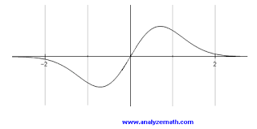

a.

b.  

c.

|  |  |  |  |  |  |
| --- | --- | --- | --- | --- | --- |
| X | -2 | -1 | 0 | 1 | 2 |
| f(x) | 5 | 3 | 0 | -3 | -5 |

12.Describe the transformation from the parent function, to the following…

a. 

b. 

c. 

**Unit 2: Geometric Sequences, Series, Exponents and Logarithms**

13. Find the explicit equation for the  term of the geometric sequence 3, -6, 12, -24, …

14. Find the sum of the first 8 terms of the geometric sequence 1, 2, 4, 8, …

15. Find the sum of the infinite series 

16. Find the value of 

17. Does the series diverge or converge? If possible, evaluate the sum. 

***Directions: For #18-21 Determine whether the function is an exponential growth or decay.***

18.  _______________________________________________

19.  _______________________________________________

|  |  |
| --- | --- |
| 20.    ___________________________________________ | 21.      ___________________________________________ |

22. A science experiment involves periodically measuring the number of mold cells present on a piece of bread. At the start of the experiment, there are 50 mold cells. Each time a periodic observation is made, the number of mold cells triples.

**a.** Write a function formula equation (*y* = ···) for the number of mold cells present, where *x* stands for the observation number.

**b.** Fill in the missing outputs of this table.

|  |  |  |  |  |  |  |
| --- | --- | --- | --- | --- | --- | --- |
| *x* = observation number | 0 | 1 | 2 | 3 | 4 | 5 |
| *y* = mold cell count | 50 | 150 |  |  |  |  |

**c.** Suppose that the mold begins to be visible as green coloration when the mold cell count exceeds 100,000. On which observation will this happen?

**d.** What will be the mold cell count on the 10th observation?

23**.** Julie gets a pre-paid cell phone. Initially she has a $40.00 balance on the phone. Each minute of talking costs $0.15. Let *x* stand for the amount of time in minutes that Julie has talked on the phone, and let *f(x)* stand for the remaining dollar value of the phone.

**a.** Is *f(x)* a linear function or an exponential function? Explain how you know.

**b.** Find a function formula equation *f(x)* = ______________________

**c.** Find the value of *f*(0) and explain its meaning in terms of the cell phone.

**d.** Find the value of *f*(100) and explain its meaning in terms of the cell phone.

**e.** Find the value of *x* that makes *f(x)* = 10, and explain its meaning in terms of the cell phone.

**f.** Find the value of *x* that makes *f(x)* = 0, and explain its meaning in terms of the cell phone.

24. You have inherited land that was purchased for $30,000 in 1960. The value of the land increased by, approximately, 5% per year. What is the approximate value of the land in the year 2015?

25. James deposited $2,500 in a bank account. Find the balance after 5 years for each of the following situations:

a. The account pays 2.5% annual interest compounded monthly.

b. The account pays 1.75% annual interest compounded continuously.

26. For each function below:

1. State whether the function is growth or decay.
2. Identify the y-intercept.
3. State how the graph has shifted.
4. Identify the domain and range.
5. Write the equation of the asymptote.
6. Graph.

i.  ii.  iii. 

a. _____________________ a. _____________________ a. _____________________

b. _____________________ b. _____________________ b. _____________________

c. _____________________ c. _____________________ c. _____________________

d. _____________________ d. _____________________ d. _____________________

e. _____________________ e. _____________________ e. _____________________

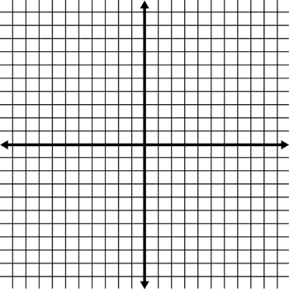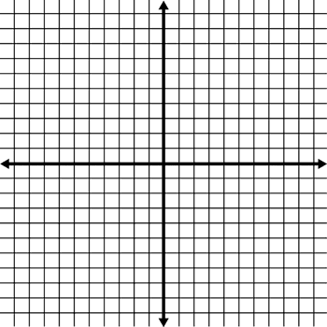

27. For each function below:

1. Identify the domain
2. Identify the range
3. State how the graph has shifted.
4. Write the equation of the asymptote.
5. State the intercepts.
6. Graph.

i.  ii.  iii. 

a. _____________________ a. _____________________ a. _____________________

b. _____________________ b. _____________________ b. _____________________

c. _____________________ c. _____________________ c. _____________________

d. _____________________ d. _____________________ d. _____________________

e. _____________________ e. _____________________ e. _____________________



28. Evaluate 

29. Write as a single logarithm: 

30. (GT only) Expand the following logarithm: 

31. Solve for x: 

32. Solve for x: 

33. (GT only) Solve for x: 

***Directions: For #34 and 35, use a calculator to approximate each to the nearest hundredth.***

34. ln 6.2 35. 

36. Expand the logarithm: 

37. Write as a single logarithm and simplify: 

38. Solve for x (round to the nearest thousandth): 

39. Solve for x: 

40. Solve for x (round to the nearest thousandth): 

**Unit 3: Statistics**

41. The temperature in San Francisco on April 14 has been recorded for the last 16 years.

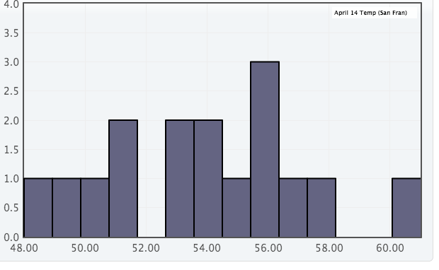Describe the shape of the distribution in context. Then choose an appropriate measure of center and an appropriate measure of spread and calculate them for this sample. Be sure to report them in context.

42. A school district is trying to determine if library assistants are necessary in schools. So they decide to take a survey and have several possible sampling methods for taking this survey. Identify the name of each sampling method and how it might lead to bias in the survey, if it does. Identify the sampling method that gives the best chance for a representative sample.

A. Randomly select 3 schools and survey everyone in the school.

B. Get a random sample of 50 people in an elementary school, 50 people in a middle school and 50 people in a high school.

C. Post the survey on the school district website and collect responses for a week.

D. Select a random sample of 500 students and employees in the school district.

43. The mean height of college-aged women is 64.5 in with a standard deviation of 2.5 in.

Part A

Draw a normal curve and label the mean and points one, two, and three standard deviations above and below the mean.

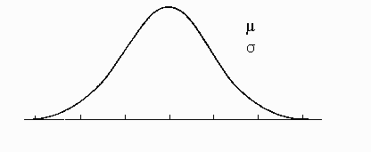

Part B

A. What percent of college-aged women are taller than 67 inches?

B. Between what heights do the middle 95% of college-aged women fall?

C. What percent of college-aged women are shorter than 59.5 inches?

44. When the school district’s survey was complete they found that 52% of the 100 people sampled believe that library assistants are necessary. The school district had believed that only 35% of the population believes that library assistants are necessary. They are going to run a hypothesis test to see if the sample results are significant evidence that they might be wrong.

Write the null and alternate hypotheses for this test.

H0:

HA:

When they ran the test they took 300 samples and the results are on the next page.

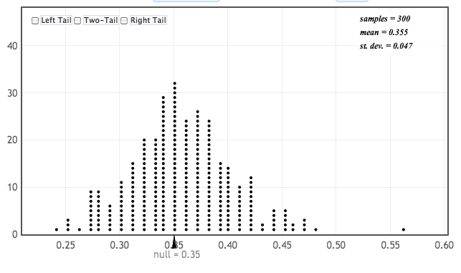Calculate the P-value for this test. Interpret the results in the context of the situation.

45. A couple was planning to move from Atlanta to St Louis because they thought they could reduce the amount of time they spent commuting to and from work. So they selected random sample of people who drive to work in Atlanta and a random sample of people who drive to work in St. Louis and found that the commuters in Atlanta spend a mean amount of 4 minutes longer commuting than the commuters in St Louis.

Determine the null and alternate hypotheses.

H0:

HA:

The results of a simulation of 400 trials are shown in the dotplot.

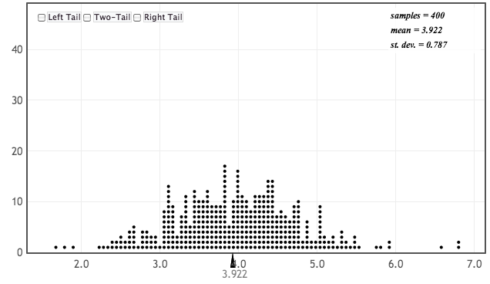

2.5

3.5

4.5

5.5

6.5

1.5

Construct a 95% confidence interval for the difference in commute times in Atlanta and St. Louis.

Interpret the interval.

Does the interval offer evidence against the null hypothesis? Why or why not?

**Unit 4: Quadratics**

46. For , identify the:

|  |  |
| --- | --- |
| a. Vertex: | _________________________________ |
| b. Max/min: | _________________________________ |
| c. Domain: | _________________________________ |
| d. Range: | _________________________________ |
| e. Axis of Symmetry: | _________________________________ |
| f. Transformations: | _________________________________ |

g. Graph:

47. For , convert to vertex form then identify the:

|  |  |
| --- | --- |
| a. Vertex: | _________________________________ |
| b. Max/min: | _________________________________ |
| c. Domain: | _________________________________ |
| d. Range: | _________________________________ |
| e. Axis of Symmetry: | _________________________________ |
| f. Transformations: | _________________________________ |

g. Graph: